GUVI task 17

1. To launch Linux EC2 instances in two different regions using a single Terraform file, follow these detailed steps:
2. Create a aws ec2 instance with a AMI (example: ubuntu) , any keypair, a security group and create it.

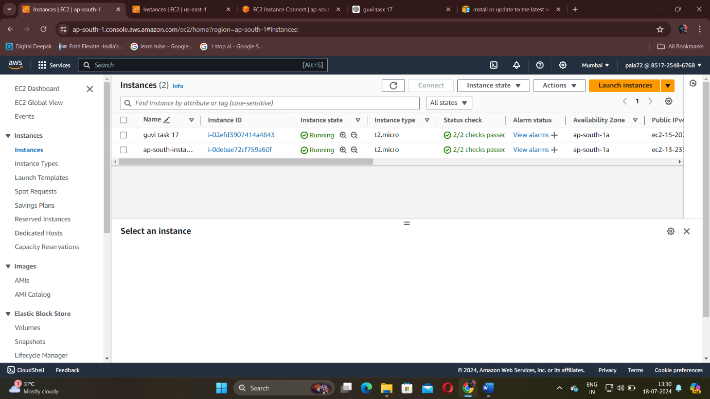

\*guvi task 17 is the instance I have created.

1. Next open the instance using https in a new tab or browser. Then check for updates , if needed type sudo apt upgrade -y.

Then install awscli, aws configure( access keys,secret access keys, availability zone, output format) . also install terraform using the documentation website.

1. Next in that instance create a directory and create a configuration file named main.tf

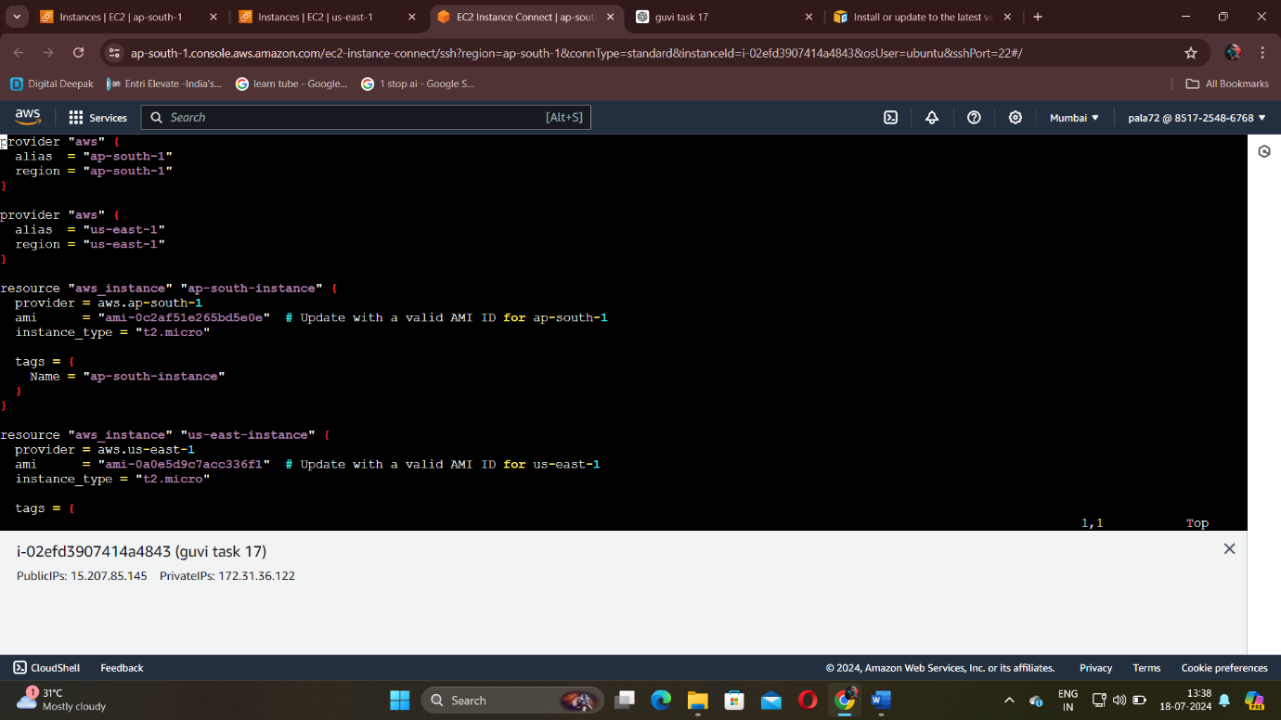

1. When creating the configuration file give the correct AMI id from the respective availability zones and give the name correctly.
2. After that do the terraform workflow commands. Ensure any error doesn’t occur in your configuration syntax.

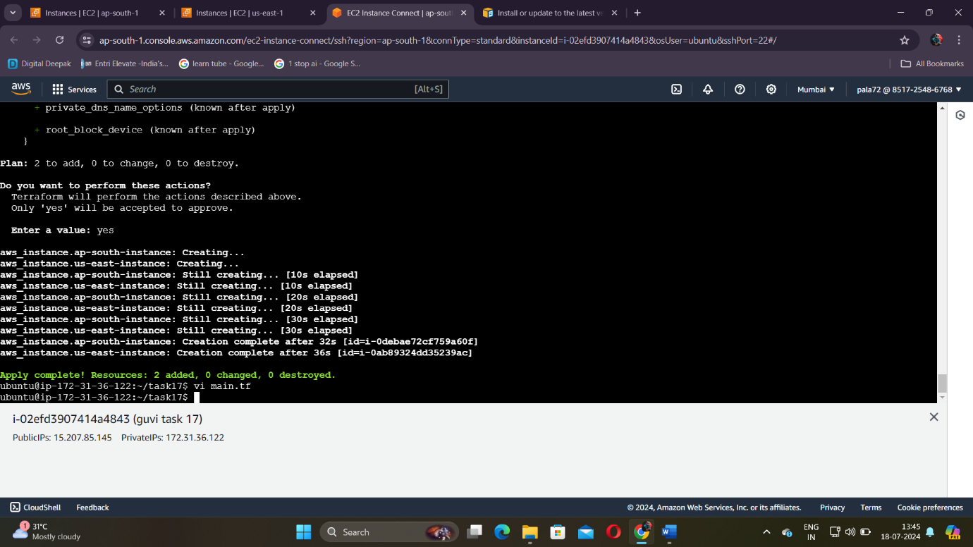

1. After entering all the workflow commands check in both availability zones you have used whether instances have been created or not.

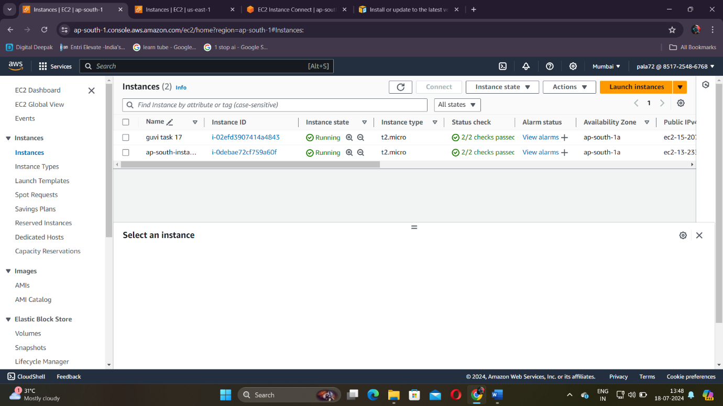

\*ap-south-instance

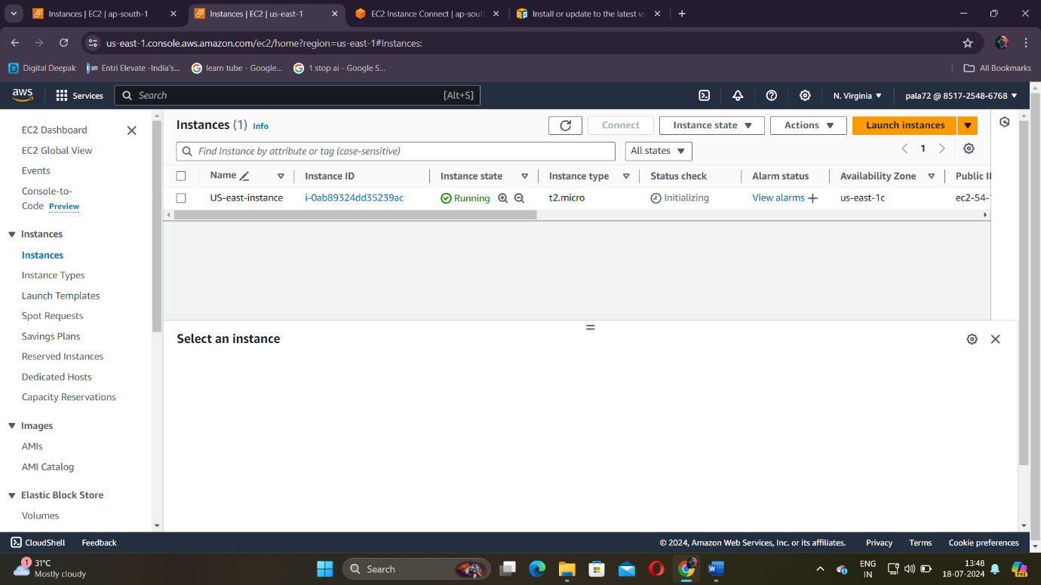

-----X-----